Department of Computer and Information Systems Engineering
CS-406 Computer Engineering Project
Proposal for the Final Year Design Project

 | Title | Machine Vision Pipeline for Steel Surface Defects Detection using FPGA SoC

Domain | Domain 1  Computer Vision (CV) | Domain 2  Embedded Systems | Domain 3  Quality Control and Assurance | Domain 4  Industrial Automation | Domain 5 | Domain 6

- Nature of Project [Tick all that applicable]
☒ New Project OR ☐ Extension of Existing Project | ☒ Industrial Collaboration | ☐ Funded
☐ Other Department Collaboration  (If yes) Department Name________________ | ☐ Other Academic Institution Collaboration  (If yes) Institution Name_______________

- Brief Outline (Problem Identification and Significance)
Steel surfaces specifically steel rods and hot rolled steel strips, are widely used in various industries including automotive, aerospace, manufacturing, and construction can have certain defects namely crescent gap, inclusion, patches, pitted surface, rolled pit, scratches, waist folding, water spot, welding line, dents, material pit, process pit, plotting cracks, roughness, which poses significant operational risks, even leading to product failure. [1]
Identifying these anomalies accurately early on in the manufacturing process is crucial in maintaining quality and safety standards and can reduce material waste, rework costs, and downtime in the manufacturing process, leading to cost savings for industries. [2]
Traditional methods of defect detection, often relying on manual inspection or basic automated systems, using conventional image processing may not offer the accuracy or speed required in high-demand production environments. Machine vision based deep learning models are a powerful tool for these challenges. [3]
However, the deployment of these deep learning models on standard general purpose CPUs results in slow processing speed and GPUs are more efficient but draw a lot more power [4], these implementations may not be optimized for industry requirements with fast paced production environments which require efficient low power real time processing.
To overcome these challenges, this project proposes deploying a deep learning model trained to detect defects on steel surfaces on a Field Programmable Gate Array (FPGA). FPGAs offer parallel processing capabilities and customization to optimize the machine learning models for improved performance while using less power than traditional CPUs and GPUs. [5]
Ultimately adopting cutting-edge FPGA based systems can provide industries with a competitive advantage by improving operational efficiency and product quality. This project can pave the way for future innovations in deep learning, FPGA based systems and their deployment and usage in industries.

- Objectives
- Utilizing custom datasets, performing necessary data preprocessing to ensure optimal training results.
- Training a deep learning model on the dataset to detect certain types of defects on steel surfaces accurately.
- Enhancing the performance of the computer vision model by hyperparameter tuning and further adjusting the dataset, to ensure optimal performance.
- Deploy the optimized deep learning model on the FPGA development board to achieve accurate defect detection with faster response times and lower power consumption.
- Evaluate and compare performance metrics of the FPGA accelerated model and traditional CPU/GPU based implementation.
- Provide a solution which aligns with industry standards, potentially setting a benchmark for automated defect detection on steel surfaces.

- Scope
- Defect Types and Surface: Focus on various types of defects, like crazing, inclusion, scratches, patches, pitted surface, welding line, commonly found in steel surfaces used in industrial applications.
- Deep Learning Model: Development of a deep learning model designed for defect detection on steel surfaces.
- FPGA Implementation: Implementation of the computer vision model on a selected FPGA platform using HDL (Hardware Description Language).
- Testing and Validation: Develop and execute test cases to ensure error free operation under different conditions, defect types and steel surfaces.
- Performance Enhancement: Optimize the deep learning model and FPGA hardware to ensure optimal performance and real time processing.
- Performance Evaluation: Comparative analysis of the FPGA-accelerated model against traditional CPU and GPU implementations. Evaluation metrics will include processing time, frames per second (FPS), and detection accuracy.

- Proposed Methodology
Utilizing custom datasets, perform necessary data preprocessing, train a deep learning model on the optimized dataset to detect certain types of defects on steel surfaces.
Optimizing the model by performing hyperparameter tuning, further adjusting the dataset, and performing other necessary operations to improve the performance of the model.
Deploying the optimized model on an Avnet Ultra96 Field Programmable Gate Array (FPGA) development board, aiming to significantly reduce processing time, enhance frames per second (FPS) and improve the overall performance of the optimized deep learning model.

Flow chart
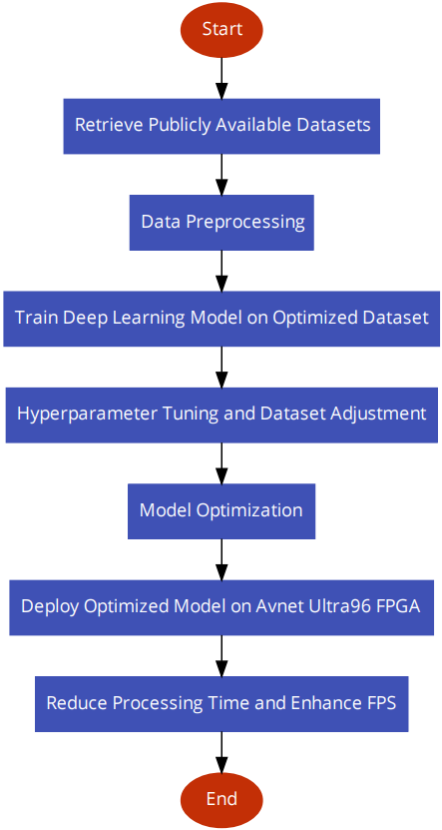

- Resources Involved
      - Research Papers
        - IEEE
        - Springer Link
        - Elsevier Scopus
      - Dataset
        - Kaggle
        - Roboflow
      - Exploratory Data Analysis Tools
        - Python
        - Pandas
        - Numpy
        - Matplotlib
      - Web Interface Development Tools
        - HTML
        - CSS
        - JavaScript
      - Deep Learning Model
      - Avnet Ultra96 FPGA Development Board
      - FPGA Development Tools
        - Vivado
        - Vitis AI
        - Hardware Description Language

- Description of Industrial Support (If any)
Support from DreamBig Semiconductor in the form of FPGA development tools and resources through Dr. Majida Kazmi(Co-supervisor). DreamBig is an emerging semiconductor startup.
Support from Agriauto in the form of data through Dr. Majida Kazmi(Co-supervisor), Agriauto is one of the leading automotive components manufacturers in the private sector.

- SDGs (If Applicable)
☐ No Poverty | ☐ Zero Hunger
☐ Good Health and Well-Being | ☐Quality Education
☐ Gender Equality | ☐ Clean water and Sanitation
☐ Affordable and Clean Energy | ☒ Decent Work and Economic growth
☒ Industry, Innovations and Infrastructure | ☐ Reduced Inequalities
☐ Sustainable Cities and Communities | ☐ Responsible Consumption and Production
☐ Climate action | ☐ Life Below Water
☐ Life on Land | ☐ Peace, Justice and Strong Institutions
☒ Partnerships

- References
[1] Z. Cheng, L. Gao, Y. Wang, Z. Deng and Y. Tao, "EC-YOLO: Effectual Detection Model for Steel Strip Surface Defects Based on YOLO-V5," in IEEE Access, vol. 12, pp. 62765-62778, 2024, doi: 10.1109/ACCESS.2024.3391353.
[2] J. Yu, X. Shi, W. Wang and Y. Zheng, "LCG-YOLO: A Real-Time Surface Defect Detection Method for Metal Components," in IEEE Access, vol. 12, pp. 41436-41451, 2024, doi: 10.1109/ACCESS.2024.3378999.
[3] K. Yang and T. Chen, "Lightweight Surface Defect Detection Algorithm Based on Improved YOLOv5," 2024 5th International Conference on Mechatronics Technology and Intelligent Manufacturing (ICMTIM), Nanjing, China, 2024, pp. 798-802, doi: 10.1109/ICMTIM62047.2024.10629491.
[4] J. Xin et al., "Lightweight convolutional neural network of YOLO v3- Tiny algorithm on FPGA for target detection," 2021 IEEE International Conference on Computer Science, Artificial Intelligence and Electronic Engineering (CSAIEE), SC, USA, 2021, pp. 65-70, doi: 10.1109/CSAIEE54046.2021.9543128.
[5] Y. Qu and J. Wang, "Design of Low-power YOLO Accelerator Based on FPGA," 2024 7th International Conference on Advanced Algorithms and Control Engineering (ICAACE), Shanghai, China, 2024, pp. 1132-1137, doi: 10.1109/ICAACE61206.2024.10548891.

- Gantt Chart
Year | 2024 to 2025
Months | Sep | Oct | Nov | Dec | Jan | Feb | Mar | Apr | May | Jun
Literature review and learning of tools (30 weeks)
Model Research & Development
Data preprocessing (1 week)
Model selection (4 weeks)
Model training, evaluation and optimizing (3 weeks)
FPGA Deployment and Implementation
Initial deployment of model on FPGA (8 weeks)
Finalize deployment on FPGA (13 weeks)
Web Interface Development
Interface and Frontend development (4 weeks)
Integration and Testing
Integration Final Testing (8 weeks)

- Details of Project Team

- Students

No. | Name | Seat No. | Signature (s)
1 | Aaliyan Mansoor | CS-21146
2 | Muhammad Maaz Khan | CS-21019
3 | Mohib Ud Din | CS-21142
4 | Muhammad Babar Ali | CS-21145

- Supervisors / Advisors
 | Name | Designation & Department | Address & Contact | Signature(s)
Supervisor | Ms. Fakhra Aftab | Lecturer, CIS | fakhraaftab@cloud.neduet.edu.pk
Co-Supervisor  (If any) | Dr. Majida Kazmi | Associate  Professor, CIS | majidakazmi@neduet.edu.pk
Industrial Advisor (If any) | Mr. Omar Razzaq | Director Operations, Agri Auto Pvt Ltd. | omar.razzaq@agriauto.com.pk
 | Mr. Fasahat Hussain | Team Lead, Senior Technical Manager, DreamBig SemiConductor | fasahat@digitekeng.com

(Signature of Chairperson)
Date:

For Office Use Only
Project Serial No.: __________  Dated: ______________ | Signature  Convener Steering Committee | Signature  FYP Coordinator

☐ Proposal Approved |  | ☐ Not Approved | ☐ Returned for Clarification / Modification
Comments:
(if any)

